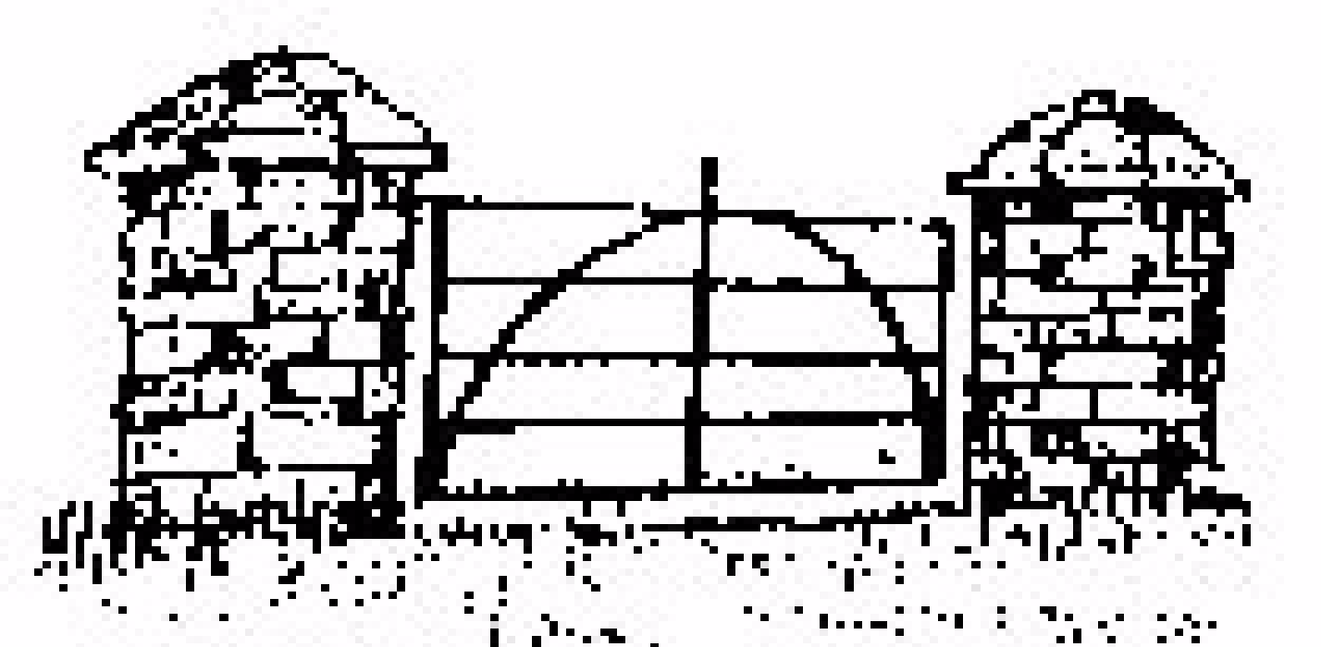
Northern Area Community Network

Membership 2025/2026

Membership Form

Membership Fee: FREE for this year
Section 1: Details
Name of Group
Main Contact Name
Correspondence Address
Postcode
Email
Telephone No.
Additional Contact Name
Email
Telephone No.
Website
Facebook
Charity Registration Number

Section 2: Eligibility Checklist
1. ☐ Our organisation is not-for-profit and operates on a voluntary or community basis.
2. ☐ We are based within or operate primarily in Causeway Coast & Glens Borough Council, Mid & East Antrim, or Antrim & Newtownabbey.
3. ☐ We support grassroots community development and are committed to improving the lives of local people.
4. ☐ We do not promote any activity that is party political in nature.
5. ☐ Our activities and communications are non-discriminatory, and we do not promote or tolerate discrimination based on religion, race, gender, colour, disability, or any protected characteristic.

Section 3: Purpose & Activities
* Brief description of your organisation’s purpose and main activities (max 100 words)

* Target groups or communities you support (e.g. youth, older people, ethnic minorities, carers)

* Do you have a governing document (e.g., constitution)? ☐ Yes ☐ No

* Are you formally constituted ☐ registered charity ☐ other?__________ ☐ (tick one or more)

Section 4: Agreement & Declaration
By submitting this application, our organisation confirms that the information provided is accurate and that we agree to uphold the values and aims of Northern Area Community Network (NACN). We understand that membership may be reviewed or revoked if we no longer meet the eligibility criteria or act in a way that is inconsistent with NACN’s principles.

Signed:

Name (print):

Role:

Date:

